Show, Don’t tell Principle

Story that should inspire world building:

“Stormwreck Isle was born when three metallic dragons, followers of Bahamut, defeated the powerful red dragon Sharruth and imprisoned her beneath the ocean floor. Sharruth’s fury and the volcanic activity caused by her imprisonment fractured the land and forced it to rise around her prison, forming the island. Since then, chromatic and metallic dragons have been drawn to the power of the place and have fought numerous battles there, leaving bones, ruins, and scars across the landscape. The deaths of so many dragons, combined with Sharruth’s essence still emanating from her prison, have infused the island with draconic energy, causing earthquakes, magical manifestations, unusual creatures, and phenomena associated with the different types of dragons.”
The world building and exploration elements should reflect that story.
Locations of Stormwreck Isle:

- Dragon’s Rest: This is where players start the adventure, and their Safe Heaven for narrative and gameplay purposes.
- Seagrove Case: A case where a myconid community lives.
- Compass Rose Shipwreck: The wreck of a ship named Compass Rose.
- Clifftop Observatory: The observatory where Sparkrender is planning and executing their schemes.
- Places of Power (5 locations): Locations where the power of dragons is concentrated in such a way that if you spend time communing with it, you are able to harness the power of a dragon.

Combat System elements:
- Permanent Injuries: When a character reaches 10% of its total health, a permanent injury from a Permanent Injury table is rolled. The character acquires this injury permanently even if its hp is recovered.

Exploration System elements of Stormwreck Isle:

- Travel system (turns, movement and actions)
- Random encounters generator (creatures, environmental hazards, Dragon Conflict Related Feature, Rewards)
- Climate generator (sunny, cloudy, raining)

Travel System:

This system includes ways of traveling through Stormwreck Isle through turns to track passage of time, listing actions or activities that players can pick in order to travel through dangerous places, and a Random encounter and Climate generator to be used in each turn. The Random Encounter Generator will be act differently in each of the 6 areas of the Isle, bringing different and unique dangers in each area.

Random Encounter Generator:
The encounters should reflect the story of Stormwreck Isle. We will try to do that by rolling multiple tables where each table will represent an aspect of the encounter. These encounters will take into consideration in which area the players characters are, in which type of terrain the encounter happens and whether the characters are in movement (eg. traveling) or stationary (eg. camping).
The Random Encounter Generator is composed of built-in generators:
- Creature Generator: These are a composition of 5 tables capable of determining what kind of creature they will be. Each table tells an aspect of the creature in the encounter. This generator requires a terrain type input (land, coastline or sea), and based on input, one of three creature tables will be selected to be rolled followed by the other two. All tables descriptions are bellow:
  - Creatures - Describes the creature involved in the encounter, sometimes also the quantity.
    - Land Creatures - Examples: Owlbear, Kabolds, Spiders, Fume Drakes…
    - Coastline Creatures - Examples: Harpies, Zombies, Giant Crabs…
    - Sea Creatures: Examples: Giant Octopus, Sharks, Dolphins.
  - Dragon Power: Describes the dragon feature the creature has, or maybe a lesser change of none. Ex.: Breath Weapon, Scale Armor, Dragon Claws, Dragon Wings, Dragon Tail, Elemental Resistencies, nothing…
  - Behaviour Generator: This generator are composed of two different tables, to generate a behaviour the two tables are rolled in sequence:
    - Posture: Describes the creature's visibility and awareness of its surroundings. Ex.: 1d4: 1 - Exposed and Distracted, 2 - Hidden and Distracted, 3 - Exposed and Alert and 4 - Hidden and Alert.
    - Activity: Describes what the creature is doing at the moment of the encounter. Ex.: Hunting, Fighting (roll another creature), Resting (sleeping, digesting a meal, wounded), Protecting (food, another creature, territory), Feeding (forages, another creature), Fleeing (another creature, environmental hazard, draconic phenomenon), Scavenging (a carcass, ruins, a camp, a wreckage), Nesting (building a nest, marking territory, preparing resting place), Socializing (playing, grooming, courting, communicating, establishing nominance), Transporting (food, building material, treasure, object), Performing a Ritual (worshiping, vocalizing, interacting with draconic energy), Causing Mischief (Stealing, damaging equipment, playing with an object or misleading another creature).
- Environmental Hazard (EH) Generator: These are a composition of 3 tables. They determine which environmental hazard the encounter will have depending on each kind of terrain the players are on. This generator receives the input of the terrain type (land, coastline or sea) the players are and rolls one of the three tables accordingly.
  - Land EH - Determine which land EH the encounter will have.
  - Coastline EH - Determine which coastline EH the encounter will have.
  - Sea EH - Determine which sea EH the encounter will have.
- Draconic Historic Feature Generator - Simple table that determines the kind of element related to the dragon's conflicts on the island the encounter will have. Ex.: Big Dragon Skeleton, Draconic Battlefield, Ruined Dragon Temple, Dragon Graveyard, Abandoned Watchtower, Crater of the Fallen Dragon, Memorial of the Three Dragons, Sharruth Cult Shrine, Bahamut Worshiping Site.
- Core Generator: This generator is responsible for determining the chances of the encounter having a Creature with its feature and behavior, an Environmental Hazard depending on a terrain, a Dragon Presence Feature, a combination of the three, or none at all. The generator receives an input which is whether the characters are in movement (traveling) or stationary (camping/resting/sleeping) the chances of encountering a Creature, a EH or Dragon Presence Feature are different.

The Random Encounter Generator starts with the Core Generator Flow, within it the Creature, Environmental Hazard and Draconic Historic Feature Generators are used. The flowchart below represents its usage:
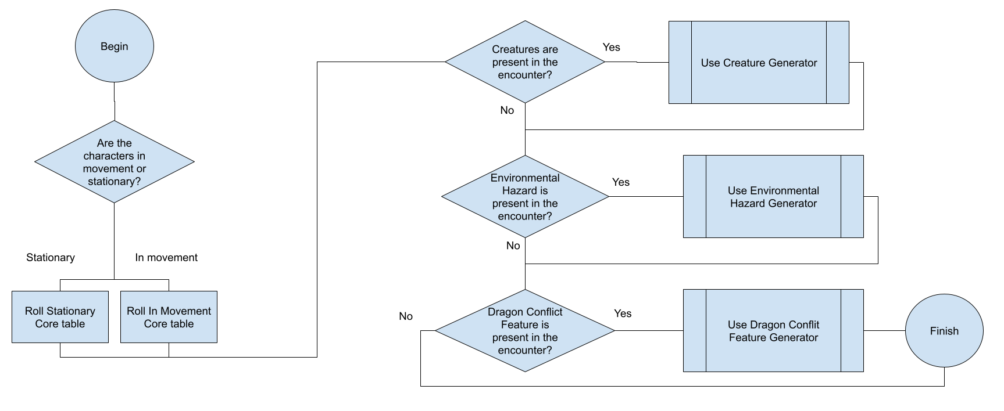

The Creature Generator flowchart is described below:
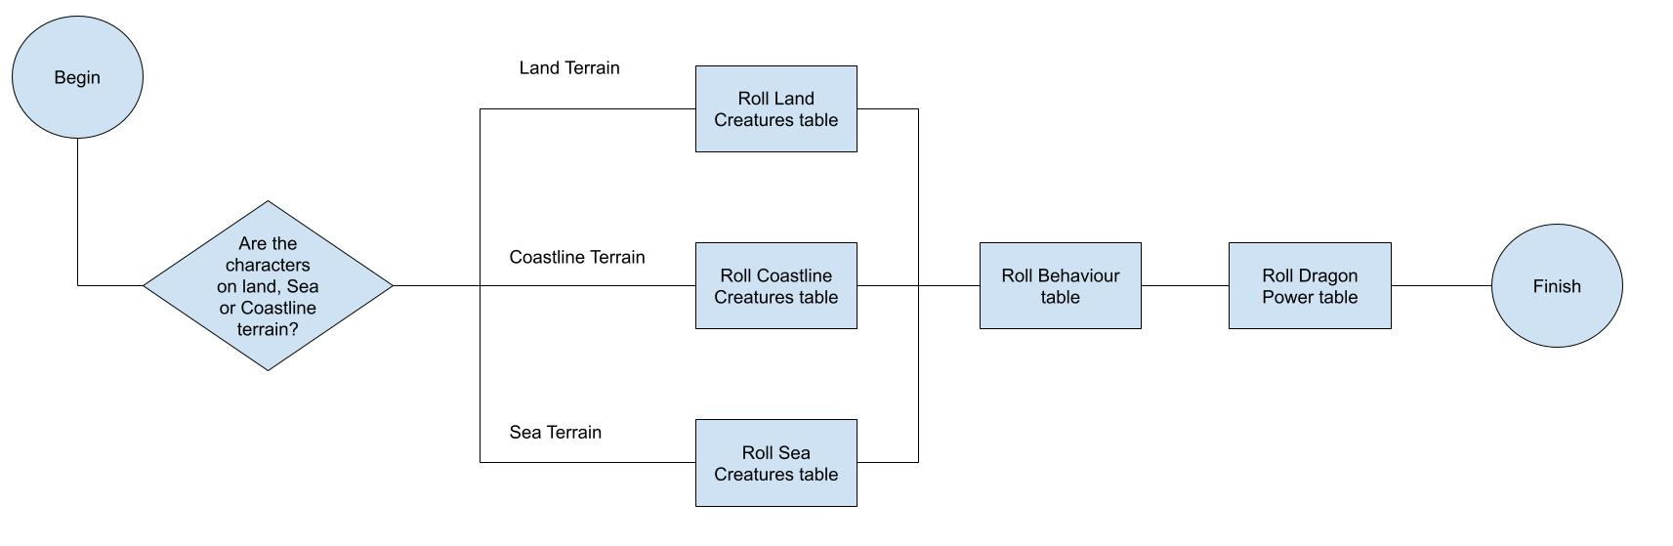
The Environmental Hazard and Draconic Historic Feature Generators have similar flowcharts because they have the same logic:
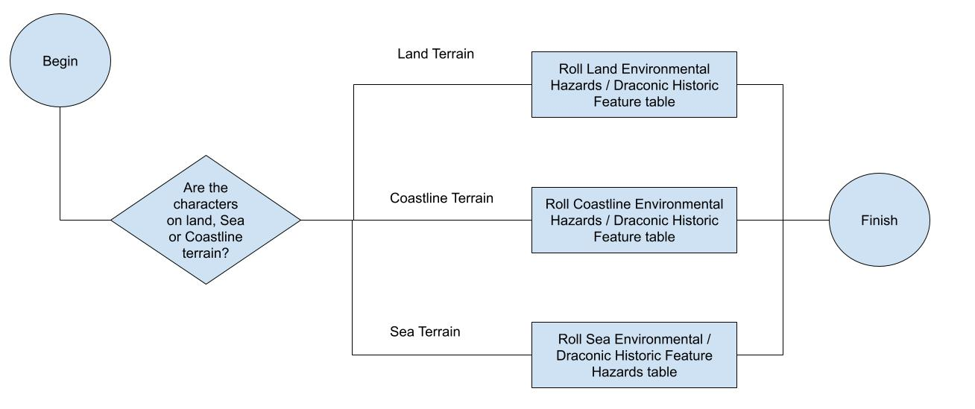
The Map of the Stormwreck Isle will have 6 different regions where the encounters will act differently. Each region tells a different story through their table entries and will have a difficulty associated with it. The encounters in one region can be harder or easier than others. It’s up to the players through investigation to find out where the safest or dangerous passage through the Isle is. Those regions are:

- Region A: A low difficult region made almost entirely by coastline and sea terrain where the presence of undead creatures is its main characteristic. The wreck of the compass rose lies here.
- Region B: A low difficult region made by all kinds of terrain where Dragon’s Rest can be found.
- Region C: A moderate difficult region located by the most east side of the Isle made by all kinds of terrain where a Dragon Power location is present.
- Region D: A moderate difficult region located by the most east side of the Isle made by all kinds of terrain where another Dragon Power location is present.
- Region E: A highly difficult region located southeast of the Isle, this is where the Clifftop Observatory is located. The region is made of all kinds of terrain.
- Region F: A low difficult region located at west south of the Isle, its where the Sea Grove cave is located and where the myconics are present.
Region A tables with its entries:
In Movement Core - 2d3:
2 - Nothing
3 - Creature, EH
4 - Creature, DPF
5 - Creature, EH and DPF
6 - EH and DPF

Stationary Core - 2d3:
2 - Nothing
3 - Creature, EH
4 - Creature, DPF
5 - Creature, EH and DPF
6 - Nothing

Coastline Creature (250 to 500 xp) - 2d2:
2 - 1d3+2 Winged Kobolds e 1d6 + 4 Kobold Warriors.
3 - 1d6+4 Lacedon Zombies / 1 Lacedon Ghoul and 1d4 + 2 Zombies
4 - 1d3 Harpies

Sea Creatures (250 to 500 xp) - 2d2:
2 - 1d3 Harpies
3 - 1d6+4 Lacedon Zombies / 1 Lacedon Ghoul and 1d4 + 2 Lacedon Zombies
4 - 1 Custom Giant Octopus. Each leg is a different medium size token, where each has HP 7, CA 14, Attributes: 15, 15, 10,8,8,8 and uses the following action: Tentacles. Melee Attack Roll: +5, reach 10 ft. Hit: 10 (1d6 + 3) Bludgeoning damage. If the target is a Medium or smaller creature, it has the Grappled condition (escape DC 13) from all eight tentacles. While Grappled, the target has the Restrained condition.

Posture - 2d2:
2 - Hidden and Distracted
3 - Exposed and Distracted
4 - Exposed and Alert

Activity - 2d3:
2 - Fleeing (another creature, environmental hazard, draconic phenomenon)
3 - Scavenging (a carcass, ruins, a camp, a wreckage)
4 - Feeding (forages, another creature)
5 - Fighting (roll another creature)
6 - Transporting (food, building material, treasure, object)

Coastline Environmental Hazard - 2d2:
2 - Treacherous Cliffs: Frequent rises and drops, combined with wet, crumbling, algae-covered rocks, make passage through this hex extremely difficult and potentially dangerous. Any encounter occurring here uses a battle map containing difficult terrain and numerous changes in elevation. Safely crossing the hex or skirting the dangerous area costs 3 hexes of travel movement. The characters can attempt to cross without paying this additional movement cost, but each character must succeed on a DC 12 Dexterity saving throw. On a failed save, the character slips, falls from one of the cliffs, and takes 2d6 bludgeoning damage.
3 - Exceptionally Strong Waves: Powerful waves continually crash over the coast, making passage dangerous. To cross this hex, each character must succeed on a DC 12 Strength (Athletics) check to avoid being struck by the waves. On a failed check, the character takes 2d4 bludgeoning damage. The characters can avoid the hazardous area by retreating along the route they came, costing 3 hexes of travel movement. If combat occurs here, roll 1d3 at the start of the first round. The result determines how many rounds pass before the next wave strikes the shore and every creature on it. The wave strikes at the end of the indicated round. At the start of the following round, roll the d3 again and repeat this process.
4 - Hidden Sea Caves: Erosion has hollowed out chambers beneath the coast, leaving portions of the ground supported by only thin layers of rock, sand, and roots. Small holes and cracks provide visible signs of the unstable ground. To cross safely, each character must succeed on a DC 12 Wisdom (Survival) check. On a failed check, the character steps onto an unstable section that begins to collapse and must succeed on a DC 14 Dexterity saving throw to catch hold of the edge. On a failed save, the character falls a considerable distance into the water of a subterranean sea cave. The cave can serve as a mini-dungeon containing creatures and rewards. On a battle map, unstable ground consists of randomly distributed 10-foot-by-10-foot areas, with at least three such areas present. Examining a particular route to identify unstable ground requires a successful DC 12 Wisdom (Survival) check and uses all of the creature’s movement for that turn.

Sea Environmental Hazard - 2d2:
2 -
3 -
4 -

- Redemoinho: sugados para o mar, o barco vira, ficam expostos no oceano (e possíveis criaturas), risco de afogamento.
- Mar agitado: risco de virar o barco, perder tempo, podem bater em pedras danificando o barco.

